Overview of Elephant & Castle Pedestrian Modelling

Spring 2014

Background

A pedestrian count at the current subway system was carried out at the end of 2012. This documented the pedestrian flows through the subway tunnels and also documented the desire lines, route choices, and behaviour of pedestrians.

This data was then used to update a pre-existing pedestrian model usingour modelling software known as Legion. This count data formed the base line for future modelling and has allowed outputs to demonstrate pedestrian behaviour, route choice and journey time under the existing and proposed arrangements.  
  
**Existing** pedestrian flows

Under the current system pedestrians use at least one of the seven subways to move through the area. Below is a diagram demonstrating the current subway system and a table listing the flows as of 2012 in each subway tunnel. These figures are two-way pedestrian flows per hour during the PM peak period, however they are for the individual subways so do include an element of double-counting

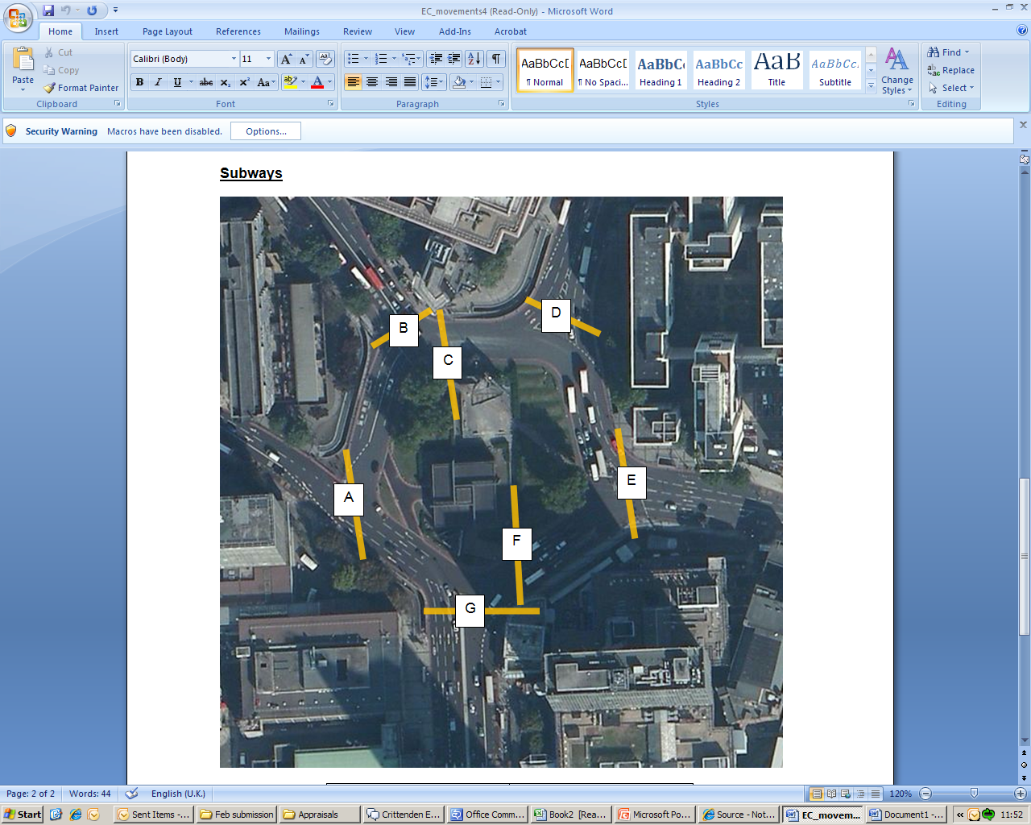

(diagram of existing subway system)

|  |  |
| --- | --- |
| **Subway** | **Pedestrian Flows** |
| A | 423 |
| B | 374 |
| C | 414 |
| D | 474 |
| E | 1,117 |
| F | 102 |
| G | 527 |

**Predicted pedestrian flows under proposed arrangement**

Under the proposed arrangement the subways will be replaced by at grade pedestrian crossings. Five of the new crossings are mapped below, with a table demonstrating the expected pedestrian usage figures for each crossing per hour during the PM peak, as above an element of double counting can be expected.

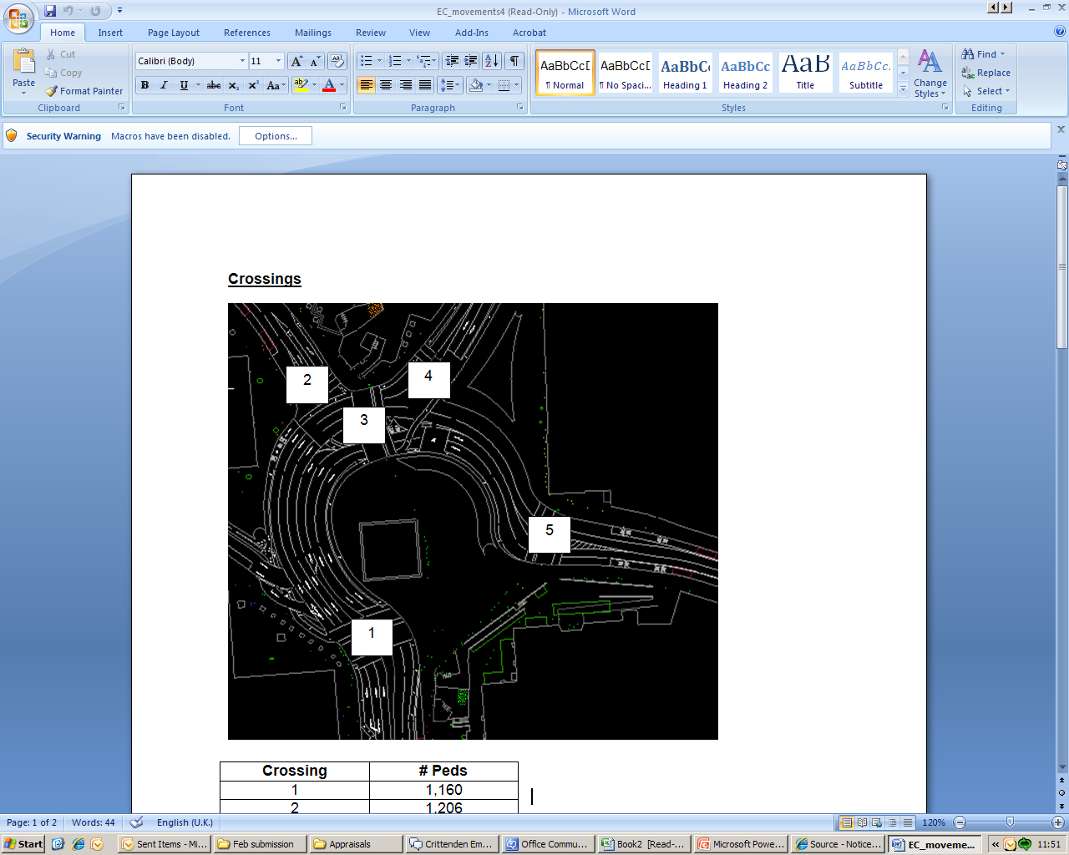

(map of new pedestrain crossing points)

|  |  |
| --- | --- |
| **Crossing Points** | **Pedestrian Flows** |
| 1 | 1,160 |
| 2 | 1,206 |
| 3 | 592 |
| 4 | 87 |
| 5 | 663 |

**Journey Time Comparison**

Journey time comparisons are made by comparing current pedestrian desire lines through the junction. These desire lines are mapped below.

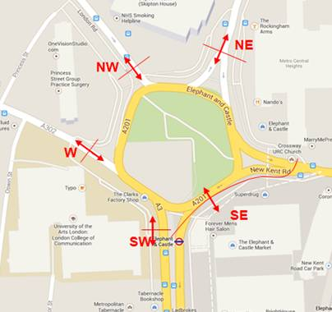

(Diagram of pedestrian desire lines end and start points)

Using our Legion modelling software we are able to compare journey times under the current arrangement and what this will be under the new arrangement. The figures are based on average journey times and use industry accepted average walking speeds (1.2m/sec) as a basis.

|  |  |  |  |  |
| --- | --- | --- | --- | --- |
| **Movement** | **Current (secs)** | **Proposed (secs)** |  | **Difference**  **(secs)** |
| NW to SW | 122 | 156.8 |  | 34.8 |
| NE to SE | 115.2 | 119.1 |  | 3.9 |
| NE to SW | 196.4 | 203.6 |  | 7.2 |
| W to SE | 122.2 | 114.5 |  | -7.7 |
| SE to NW | 167.2 | 176.2 |  | 9 |
| SE to NE | 112.3 | 157.9 |  | 45.6 |
| SE to W | 135.4 | 103.6 |  | -31.8 |
| SE to SW | 69.8 | 71.3 |  | 1.5 |
| SW to SE | 48.8 | 66.7 |  | 17.9 |